
Pegasys Attachment Procedures

- Pegasys allows for the creation of attachments that are associated with particular forms or documents. Attachments can be uploaded before a form has been submitted or after a document has already been processed. If a user has additional supporting information in the form of a Word document, a PDF, an Excel document, etc. that is saved on his or her computer, it can be uploaded to the form or document. Once uploaded it can be viewed by those having the proper credentials in Pegasys.

- From the Header page, click Attachments below the breadcrumbs track on the top of the page

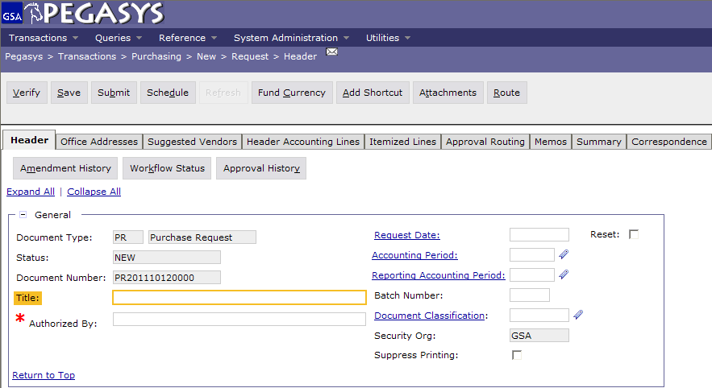

- On the Attachments page, be sure to click Import Local File (the user will not be able to fill in the fields below until they have imported the file first)

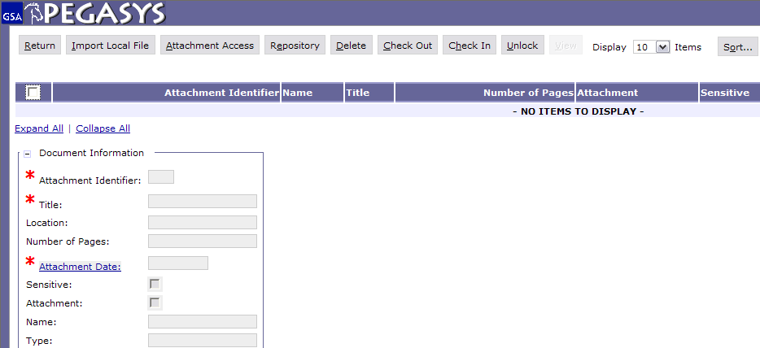

- On the Upload Document page, the Identifier field will automatically get populated with the attachment number. Fill in all the asterisked fields (Identifier, Title, & Attachment Date). Click Browse to locate the file to be attached. After you have the file selected, check the box next to Attachment if you want the document to remain attached when you Copy Forward and then click Upload. If you don’t click the box next to Attachment, the document will only appear on the original form.

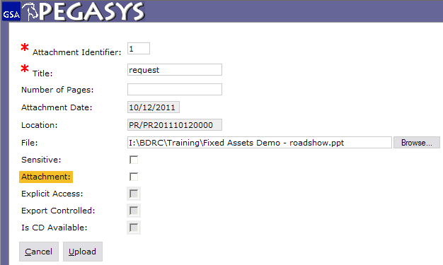
Check box for document to remain attached during copy forward
Automatically Populated

- Click Verify, click Save, then click Submit.

Note: If you wish to add an attachment to a document that has already been processed, follow the exact same procedure outlined in the steps above and then re-submit the document for processing.

